**JOBSHEET 8**

**LATIHAN**

**Latihan 1**

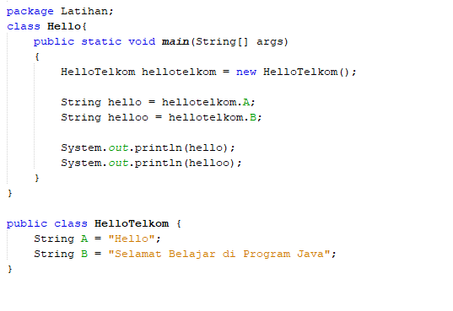

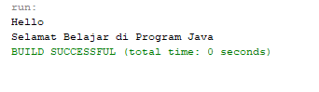

**LATIHAN 2**

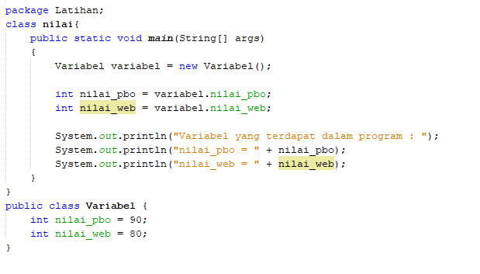

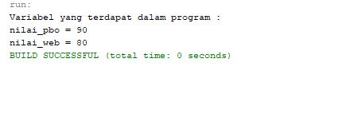

**LATIHAN 3**

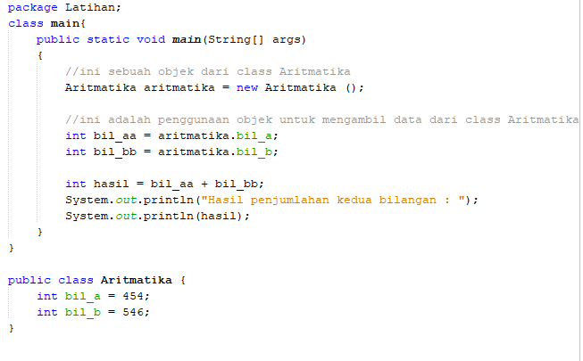

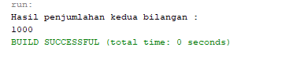

**LATIHAN 4**

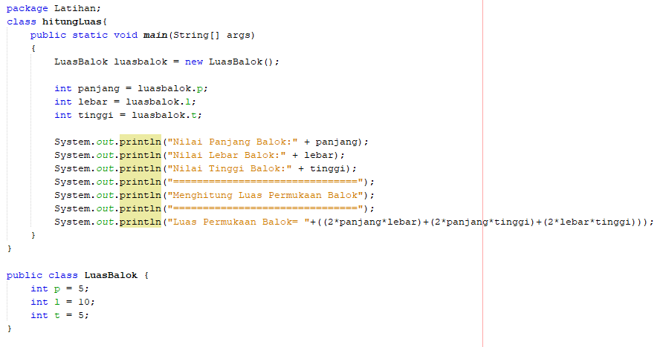

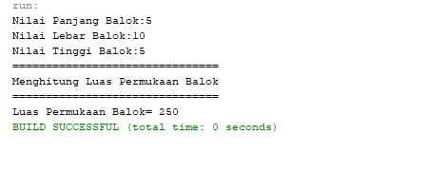

**LATIHAN 5**

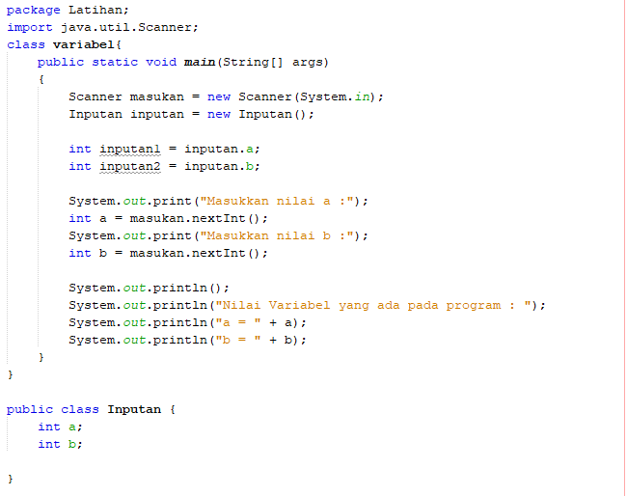

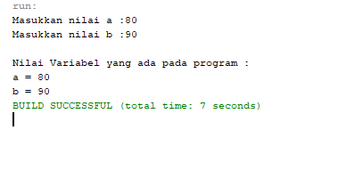

**LATIHAN 6**

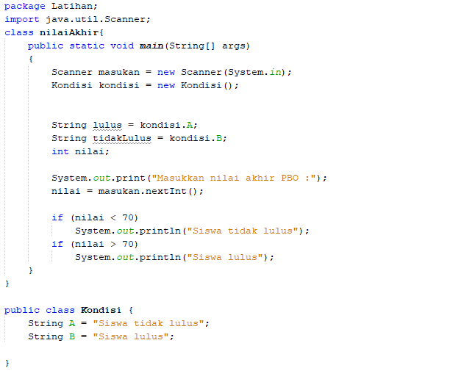

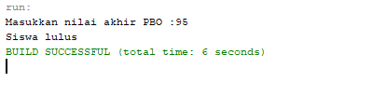

**LATIHAN 7**

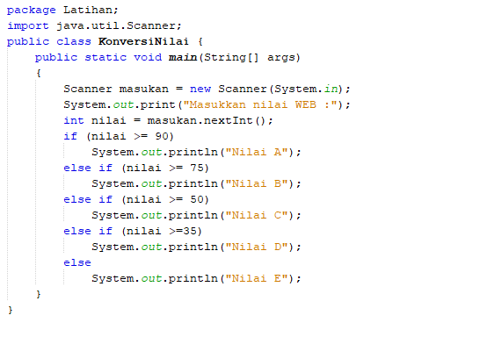

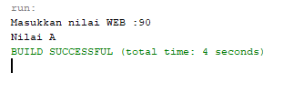

**LATIHAN 8**

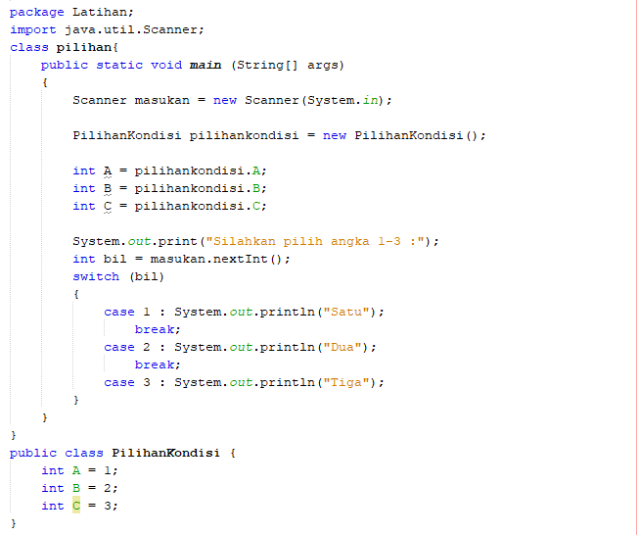

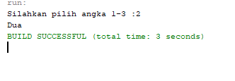

**LATIHAN 9**

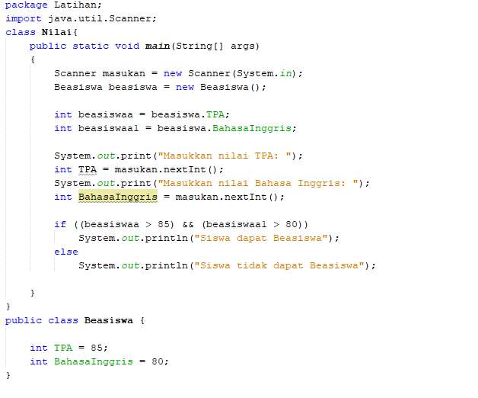

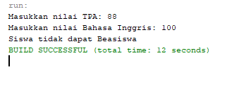

**LATIHAN 10**

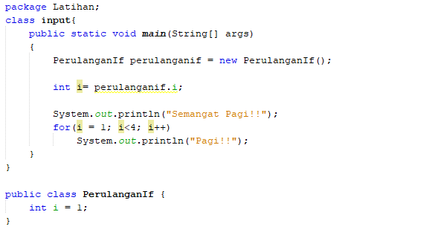

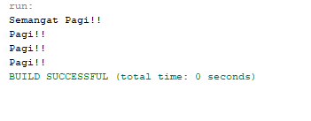

**LATIHAN 11**

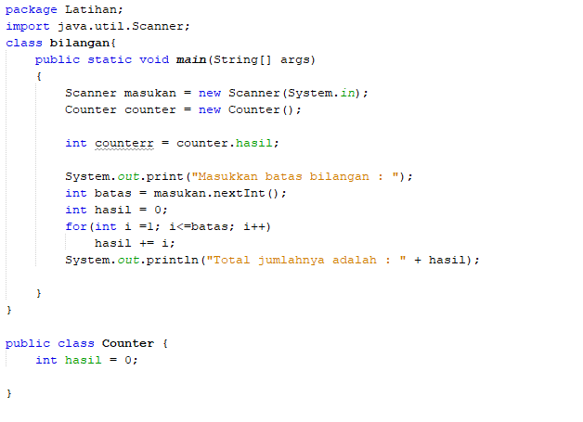

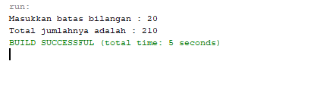

**LATIHAN 12**

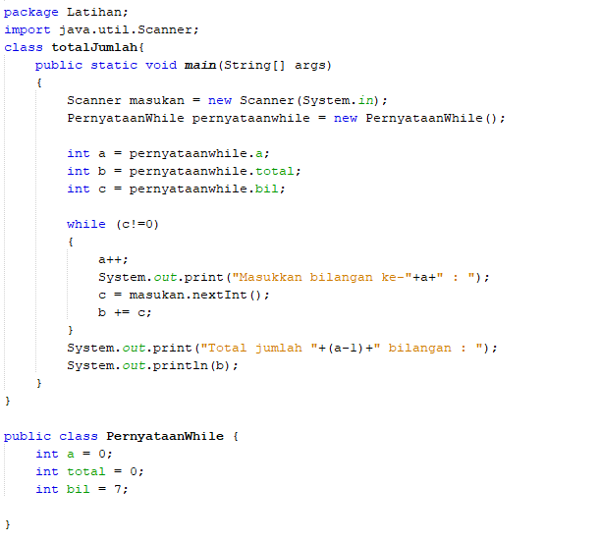

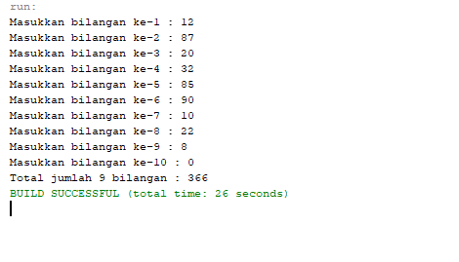

**TUGAS 01**

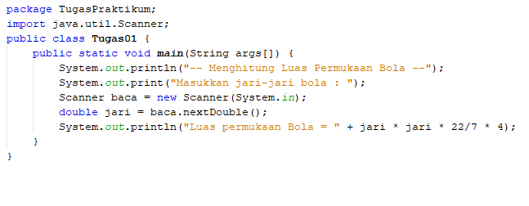

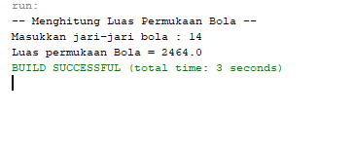

**TUGAS 02**

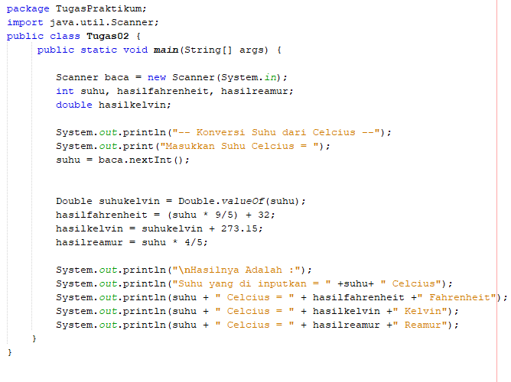

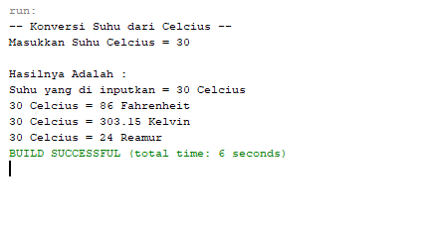

**TUGAS 03**

package TugasPraktikum;

import java.util.Scanner;

public class Tugas03 {

public static void main(String[] args) {

Scanner baca = new Scanner(System.in);

String nama, nis, Tempatlahir, Tanggallahir, Jeniskelamin, alamat, motto;

System.out.print("Masukkan NAMA = ");

nama = baca.nextLine();

System.out.print("Masukkan NIS = ");

nis = baca.nextLine();

System.out.print("Masukkan TEMPAT LAHIR = ");

Tempatlahir = baca.nextLine();

System.out.print("Masukkan TANGGAL LAHIR = ");

Tanggallahir= baca.nextLine();

System.out.print("Masukkan JENIS KELAMIN = ");

Jeniskelamin = baca.nextLine();

System.out.print("Masukkan ALAMAT DI MALANG = ");

alamat = baca.nextLine();

System.out.print("Masukkan MOTTO HIDUP = ");

motto = baca.nextLine();

System.out.println(" ---- ");

System.out.println("Nama : " + nama);

System.out.println("NIS : " + nis);

System.out.println("Tempat Lahir : " + Tempatlahir);

System.out.println("Tanggal Lahir : " + Tanggallahir);

System.out.println("Jenis Kelamin : " + Jeniskelamin);

System.out.println("Alamat di Malang: " + alamat);

System.out.println("Motto Hidup : " + motto);

}

}

